**12. Machine Knitting**

**Errol Wood**

**Learning objectives**

On completion of this lecture you should be able to:

* Outline the fibre and yarn requirements for machine knitting, with an emphasis on the suitability of wool yarns
* Describe and explain the function of key parts of a knitting machine
* Explain the features, operation and products of the main types of knitting machine and compare their advantages
* Compare knitted and woven fabrics, in particular their respective advantages and disadvantages
* Briefly describe the purposes and methods of finishing treatments commonly used with knitwear
* Describe, using simple diagrams, the most common knitted loop structures and their specific contributions to fabric appearance and performance

**Key terms and concepts**

Waxing, latch needle, needle bed, needle trick, gauge, sinker, cam, yarn carrier, courses, wales, weft knitting, fully fashioned knitting, V-bed knitting, complete garment machine, circular knitting, single jersey, double jersey, jersey stitch, rib stitch, purl stitch, interlock stitch, face side, reverse side, welt stitch, tuck stitch, milling, pilling.

**Introduction**

Knitting as a method of converting yarn into fabric begins with the bending of the yarn into loops. These loops are then intermeshed with other loops of the same open or closed configuration in either a horizontal or vertical direction. These directions correspond respectively to the two basic forms of knitting technology – weft and warp knitting.

Weft knitting can be described as the sequential formation and interlinking of a horizontal row of loops, formed from a single yarn supplied in sequence to each needle, with the previously formed horizontal row of loops. The horizontal (widthwise) rows of loops are known as *courses* and the vertical (axial) rows of loops are known as *wales*. Figure 12.1(a) shows the simplest weft knitted structure known as plain knit or single jersey. Weft knitting can be carried out manually using a pair of long knitting needles.

Warp knitting is the sequential formation and interlinking of loops in an axial direction on a lateral array of needles with at least one separate thread being supplied to each needle. The loops are joined together in a widthwise direction by moving the threads back and forth between adjacent needles. Figure 12.1(b) shows a warp knitted structure. Unlike weft knitting, there is no manual equivalent to machine warp knitting.

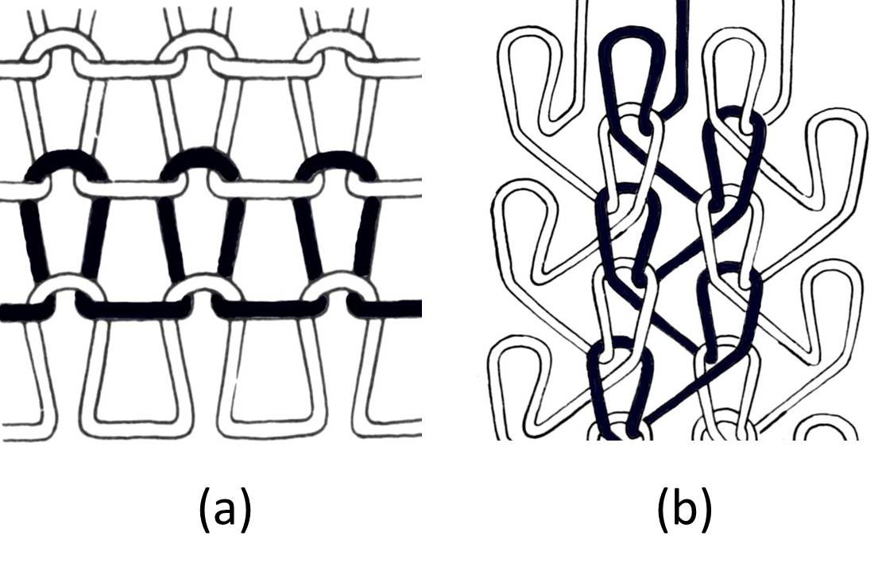

**Figure 12.1 Weft knitted (a) and warp knitted (b) structures Source: Wood, 2010.**

The loop structure in a knitted fabric may not usually be noticeable because of the effect of structural fineness, fabric distortion, additional pattern threads or the masking effect of finishing processes. The properties of a knitted structure are largely determined by the interdependence of each stitch with its neighbours on either side and above and below it.

In recent decades few sectors of the textile industry have grown as rapidly as the machine knitting industry. Advances in knitting technologies and fibres have led to a diverse range of products on the market, from high quality apparel to industrial textiles. The knitting industry can be divided into four groups – fully fashioned, flat knitting, circular knitting and warp knitting (Figure 12.2). Within the wool industry both fully fashioned and flat knitting are widely used. Circular knitting is limited to certain markets while warp knitting is seldom used for wool. Therefore, this topic will focus on weft knitting.

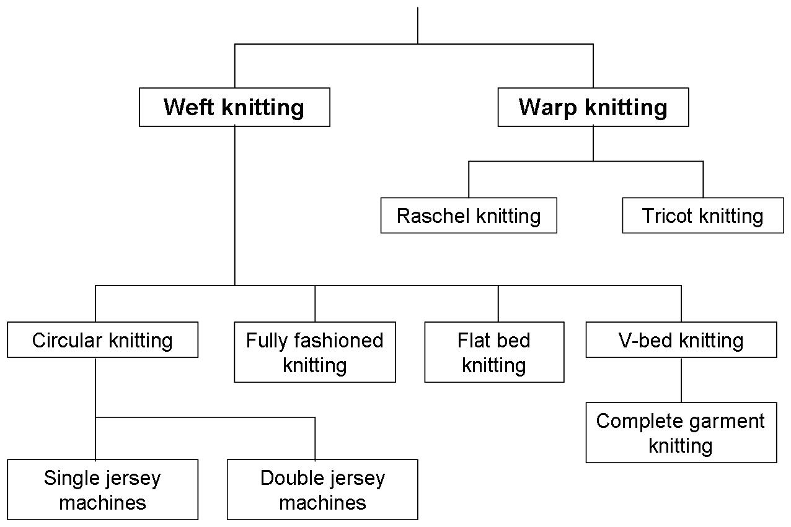

**Figure 12.2 Types of machine knitting. Source: Wood, 2010.**

A number of texts are useful as general references for this topic; (Wignall, 1964), (Gohl and Vilensky, 1985) and (Spencer, 1986). Good internet resources on machine knitting are available on the AWI ([www.wool.com](http://www.wool.com)) and Knitepedia ([www.knitepedia.co.uk](http://www.knitepedia.co.uk)) websites.

**12.1 Fibre requirements for machine knitting**

Knitted fabrics, like woven fabrics, can be made from a wide range of fibres and can have many textures (soft or firm, loose or tight, stiff or elastic and rough or smooth).

Yarns used in knitting should be strong, resilient, bulky, have good elasticity and the ability to absorb moisture. These properties depend mostly on the characteristics of the fibres used, as well as the construction of the yarn (ie, twist, count, etc.).

Knitting has traditionally used a wide range of natural fibres such as wool, silk, cotton and flax. During the 20th century the arrival of man-made fibres (regenerated and synthetic) added greatly to the list of fibres now used.

The current list of widely used fibres in knitwear is:

1. Animal fibres: wool, mohair, angora, silk, cashmere, alpaca, vicuna
2. Vegetable fibres: cotton, linen ramie
3. Manmade fibres: rayon, nylon (polyamide), polyester, acrylic, lycra

The dominant fibres for knitted apparel are nylon, polyester, the acrylics and wool.

**Wool in knitwear**

Wool yarns are ideal for most types of knitted fabrics and have the appropriate mechanical properties for efficient knitting. Wool accepts dye well, is naturally flame-retardant, remains warm even when wet and sheds water better than other yarns. It can be given a shrink-resist treatment to make it easy care in washing, however if a wool garment is agitated in water that is too hot it will shrink.

However, wool has always been considered a problem yarn for machine knitting because various difficulties may be encountered in converting it into fabric. Slow machine speeds, low knitting efficiencies, high costs of manufacture and lack of versatility in cloth design have tended to exclude wool from certain modern trends in knitted product development. Basically, the problems of knitting wool yarns are mainly due to its relatively low tensile strength, especially in comparison with continuous filament synthetics. Consequently, if, during the knitting cycle large stresses are experienced by the yarn, fabric faults such as holes will readily occur when the yarn breaks. Yarn thickness faults such as unevenness, thick and thin places all contribute to knitting inefficiencies. Hence, with wool it is obvious that high quality yarn is required for knitting.

Despite these limitations, its exceptional aesthetic and comfort properties have ensured a strong, consistent demand for knitted wool products.

Because of the influence of fibre diameter on the bending properties of yarns (as well as its relationship with fibre crimp), it is generally of more importance than fibre length. In general, the finer the mean fibre diameter (micron) of the wool, the softer the handle of the fabric and the greater the bulk (which is influenced by fibre crimp).

The fibre diameter distribution is also important, for comfort reasons. In the case of fine machine knitting yarns used for underwear in particular, the probability of any fibres producing unpleasant prickle sensations when protruding from the fabric surface must be reduced to a minimum. For this reason tops finer than 20 microns are used for such products in order to guarantee that the percentage of prickle-causing fibres (ie, those coarser than 30 microns) will be negligible.

Because of its effect on yarn strength and evenness, fibre length affects processing efficiency in yarn manufacture as well as having an influence on the appearance and wear performance of knitted fabrics (especially the propensity for pilling).

The colour of the wool is also important, but this is not often an issue with dyeing fine merino fleece wools which are generally very white in comparison with coarser wool types.

**Other fibres**

The development of synthetic fibres and their texturing processes to provide bulk has proved very beneficial to the knitting industry. Staple fibre yarns are used for many applications. Continuous filament is used for hosiery and some fabrics and is also used for reinforcement, for example, in socks. Very extensible elastane fibres such as Lycra are used as a minority component in stretch fabrics to provide high elasticity.

Acrylic fibres are the most widely used synthetic fibres in knitting yarns. They are resilient, moderately strong, relatively inelastic, feel good to the hand and are light in weight. They are easily made to imitate natural fibres and so they provide a cheap alternative to wool. However, acrylic knitwear fabrics cannot wick away moisture from the body so their warmth diminishes when they get wet. Acrylics are often used to produce novel textures not possible with natural fibres.

Nylon knitwear is lightweight, strong and elastic, resists abrasion and is easy to wash. Nylon is usually blended with wool to impart its strength to the wool, or used to strengthen section of garments that will encounter wear such as the heels of socks.

**12.2 Yarns for machine knitting**

Machine knitting requires relatively fine, smooth, strong, even yarns which have good elastic properties. Therefore the worsted system is the preferred yarn manufacturing route, although woollen-spun yarns also have their uses in knitwear, especially where a bulky, hairy yarn is required.

Knitting yarns tend to be of lower twist than weaving yarns, and may be textured (eg, crimped) to produce a fabric that is softer, more bulky and porous than woven apparel fabrics.

Both singles and folded yarns are used in knitting, but the best results are obtained with folded yarns. Tightly twisted yarns display the texture of a knitted pattern to its best advantage, while low twist, fuzzy yarns obscure the stitch pattern but produce knitwear with a more bulky appearance, softer handle and more warmth.

**Yarn treatments**

A number of treatments may be carried out to prepare a wool yarn for machine knitting. These include dyeing, steaming, clearing and winding, and waxing.

**Dyeing**

For single colour garments, the simplest solution is to use undyed yarn and sell undyed garments. The garment can be subsequently piece dyed if it composed of one fibre, or when the trims are of a different gauge and knit structure to the body of the fabric. Other colouration options are:

* **Loose stock dyeing**, which provides a wide range of colour effects which are guaranteed to be even throughout each knitted garment.
* **Top dyeing**, the most reliable method to ensure evenness of colour throughout every garment and the use of dyestuffs at maximum fastness.
* **Package dyeing**, which is safe when knitted into patterned fabrics, but involves some risk when knitting single colour non-patterned fabrics.
* **Solution dyeing**, where synthetic fibres are coloured prior to extrusion producing a highly stable, even colour.

**Steaming**

It is common to steam yarns in order to reduce the twist liveliness so that the yarn can be wound and knitted in a satisfactory manner. However, some decrease in knitting performance inevitably occurs in steaming so the severity of the treatment conditions needs to be kept to a minimum while ensuring that the steam penetrates throughout the package.

**Clearing and winding**

This is an important stage as it provides an opportunity to remove yarn defects and also is an ideal stage for the addition of knitting lubricants.

Knitting efficiency can be affected by the incidence of faults in the yarn. For medium to coarse counts, knitting faults are mainly a result of thick places in the yarn (eg, slubs, knots). Finer yarns, however, mostly break at the thin places and are rarely affected by knots. A clearing device automatically detects thickness faults, removes the section of yarn by cutting and re-joins the yarn.

The winding of the cleared yarn onto a cone is carried out under even tension. Excessive winding tension must be avoided as this can lead to flattening and distortion of the yarn, adversely affecting fabric appearance. Because of the unwinding conditions on the knitting machine, a knitting yarn package needs to have a greater taper to prevent the unwinding yarn fouling the edge of the package.

**Waxing**

In knitting, the yarns are threaded around numerous guides and into the needles and tension builds up in the yarn due to friction between the yarn and the guides and needles. Frictional forces opposing yarn motion can cause excessive yarn breakage in knitting. Yarn lubrication to reduce these forces is an important part of the preparation of knitting yarns. Paraffin wax is often used for this purpose and is normally applied by means of wax rings during the winding process. Proper waxing ensures that a constant yarn tension is maintained throughout the knitting process. It is recommended that the average wax take-up be around 2 grams per kilometre of yarn

No all knitting yarns are waxed before leaving the spinning plant. This is because if the storage conditions are too warm, the wax can melt and penetrate into the yarn, thus significantly reducing its effectiveness.

**Yarn construction**

**Yarn count**

For a given knit structure, the fineness (or coarseness) of a yarn (ie, its count) can make a large difference in the appearance of the fabric. Knitters with machines of varying gauge may feed in additional yarns to boost the yarn count.

For example, a 10 gauge machine may use a single end of yarn while a 6 gauge machine may have two ends of this yarn fed in. This is preferable to purchasing an extra yarn with its count specifically selected to match the knit gauge.

**Yarn twist**

The yarn twist has an influence on its strength and extensibility. High twist results in a firmer, leaner yarn and can give a high level of stitch clarity in knitwear. The fabric will also tend to be somewhat thinner (ie, lower bulk), more permeable to air and possible feel a little harsher to the touch.

However, knitting yarns are not subjected to the same high abrasion forces as weaving yarns. They tend to be of lower twist than weaving yarns, and may be textured to produce a fabric that is softer, more bulky and porous than woven apparel fabrics.

Yarns of a given count and with low twist will tend to have a lofty, soft, warm appearance while the same yarn with higher twist will produce a fabric which is relatively lean, firm and cooler.

Variations in yarn twist have the following effects on the resultant fabric:

* Increasing twist generally reduces pilling problems,
* Increasing twist involves additional yarn cost (cents/kg).

**12.3 Parts of a knitting machine**

**Knitting needles**

In machine knitting a series of needles is used to form the stitches. They perform different functions depending on the knitting technique and the needle type.

A knitting needle has a hook at one end to catch the yarn forwarded to the knitting zone, a stem (or shaft) to carry the knitted loop during the early stage of the loop formation process and a butt at the other end. The butt is used either to position the needle on a needle bar or to move the needle during the stitch formation process. At the start of the knitting cycle (to form a stitch) the hook of the needle is opened to release the retained knitted loop and to receive the new yarn loop, which is then enclosed in the hook. Before the new yarn loop can be drawn through the knitted loop (linking up) the loop must be closed (bridge formation) for the knitted loop to slide over the closed hook. Thus all needles must have a means of closing and opening the needle hook – there are three ways in which this may be achieved:

1. applying an external force, as in the bearded needle;
2. using movement of knitted loop relative to knitting needle, as in the latch needle;
3. using an additional closing element, as in the compound needle

**Latch needle**

The latch needle (Figure 12.3), which was invented by Matthew Townsend in 1849, has the advantage over the other types of being self-acting or loop controlled. Hence it is the most widely used needle in weft knitting.

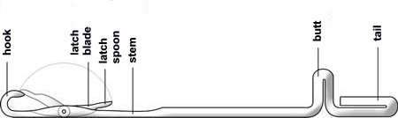

**Figure 12.3 Latch needle Source: Wood, 2010.**

A latch needle has the following key parts:

* the hook which draws in and retains the new yarn loop;
* the latch blade;
* the latch spoon (an extension of the latch blade and bridges the gap between the hook and the stem covering the hook when closed);
* the stem (or blade) which carries the loop in the clearing or rest position;
* the butt which enables the movement of the needle by using cams.

The sequence in which a latch needle produces a knitted loop is shown in Figure 12.4.

1. The stitch previously formed is in the hook. The latch is either open or closed.
2. The needle is raised until the stitch passes behind the latch on to the stem of the needle.
3. The yarn which will form the following stitch is laid in the hook. The latch is open.
4. The needle is drawn downwards. The preceding stitch closes the latch then falls beyond the hook over the new stitch.
5. The needle is ready to form the next stitch (as in step 1).

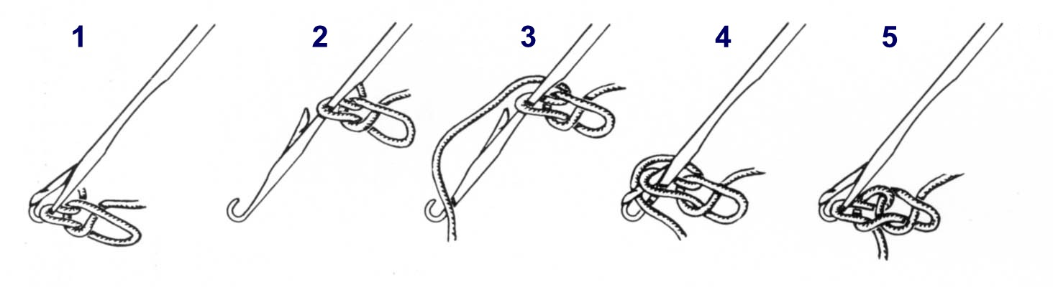

**Figure 12.4 Formation of a stitch with a latch needle. Source: Wood, 2006.**

**Needle beds**

The needle bed holds the needles at specific distances and guides them during the stitch formation process. To achieve this control, the needles are placed in slots called *needle tricks* on a needle bed. Needle beds are of two main forms (Figure 12.5):

1. Flat form: a rectangular thick metal plate is used to make the needle bed, which is used in flat bed knitting machines, where the tricks are parallel.
2. Circular form: a metal cylinder or metal disc (or dial) is used to make the needle beds for circular knitting machines. If a metal cylinder is used to make a cylindrical needle bed the tricks are machined parallel to the axis of the cylinder. If a metal disc is used to make a dial needle bed, the needle tricks are not parallel, but instead they are all pointing towards the centre of the dial.

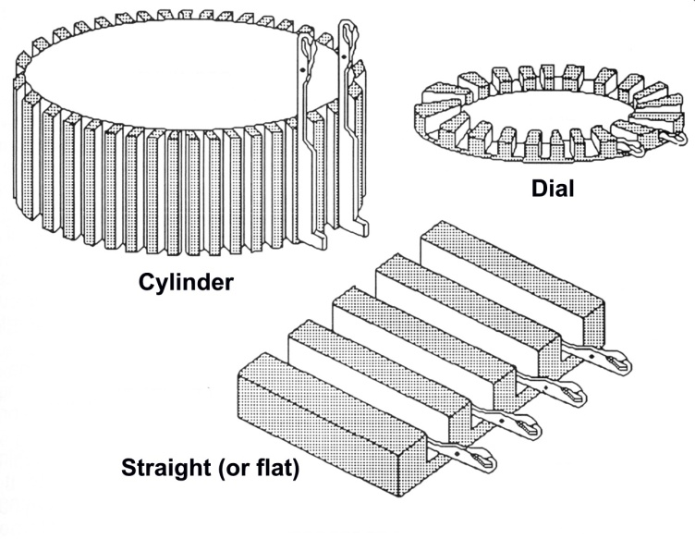

**Figure 12.5 Types of needle beds. Source: Wood, 2010.**

Industrial V-bed knitting machines are equipped with two flat needle beds, arranged to form an inverted V, hence the name.

Needle beds are specified by

1. the *machine gauge*, which is the related to the distance between two neighbouring needles. The English gauge is the number of needles per inch (Figure 12.6).
2. the *maximum width of fabric* that can be knitted. In flat bed machines this is the distance between the first and last needle in the needle bed. In circular machines it is the circumference of the needle cylinder.

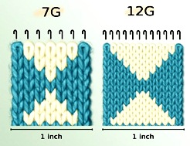

**Figure 12.6 Knitting gauge. Source: Wood 2010.**

Other important parameters of the needle bed are (1) the width, height and base of the trick, and (2) the height of the needle bed.

Figure 12.7 shows a cross-section of the needle bed in a typical V-bed knitting machine.

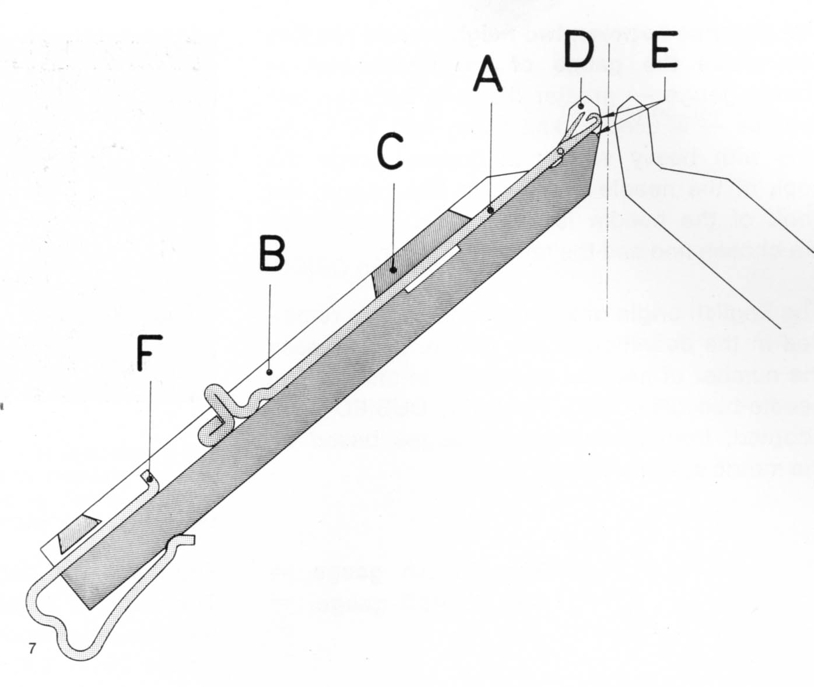

**Figure 12.7 Cross-section of a needle bed in a V-bed machine. Source: Wood, 2010.**

A – needle,

B – trick wall separating two neighbouring tricks,

C – needle cover band maintains the needles against the base of the trick. The needles slide freely under the band.

D – jack or knocking over bit of the needle bed

E – front of the jack. The jack and the front of the jack with which the thread comes in contact with during knitting is a special shape and polished to ensure the easy sliding of the stitch without damage to the yarn.

F – needle security spring which ensures that the needle is maintained sufficiently high in the needle bed for the inside angle of the raising cams to pass underneath the butt of the needle.

**Sinkers**

A sinker is a thin piece of metal acting as a divider blade which is used to perform a number of tasks in the loop formation process. Sinkers are generally placed at 90o to the needle bed and can be either fixed to a bar, or held on the end of a pivoting lever. The sinkers fall between needles and form loops from yarn laid across the needles. Subsequently they are used to move the course of loops on and off the needles.

A second and more common function of sinkers is to hold down the old loops at a lower level on the needle stems than the new loops which are being formed. They prevent the old loops from being lifted as the needles rise to clear them from their hooks. Figure 12.8 shows sinkers in weft knitting with a latch needle in position, ready for the formation of a new loop.

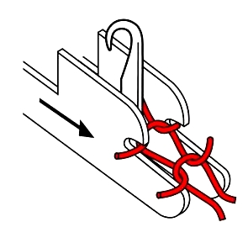

**Figure 12.8 Sinkers in weft knitting using latch needles. Source: Wood, 2010.**

**Cams**

The raising and lowering movements of the needles are caused by inclined planes which operate in the butts of the needles. The planes, called *cams* (Figure 12.9) are fixed to a cam plate. The front and rear cam plates form the carriage of a V-bed machine.

Knitting cams

**Figure 12.9 Cam system of a flat bed knitting machine. Source: Wood, 2010**

Lowering and raising cams are used in all types of knitting machines with latch or compound needles, whether they are circular weft knitting machines, flat bed weft knitting machines, hand driven or automatic.

During the stitch formation process the needles may or may not need to be activated, depending on the knitted structure to be produced. This is easily achieved by mechanisms that prevent the butt of the needle coming into contact with the raising edge of the raising (or clearing) cam.

**Yarn carriers**

A *feed* is a place in the knitting machine where (1) the yarn is fed to the needles, (2) the needles are activated, and (3) stitches are produced. Therefore, a feed consists of cams, a yarn carrier and needles travelling past. Yarn carriers are the devices that carry (or feed) the yarn to the needles. On flat knitting machines the yarn carriers move past the needles while on circular machines the yarn carriers can be stationary (and the needles move past) or they can rotate past the needles.

If all the needles are knitting at each feed then each feed will produce one course in the fabric. For example, a 12-feed circular machine, with all needles forming stitches at every feed, will produce 12 courses per revolution of the machine, ie, 12 needles are producing stitches simultaneously. This knitting action creates a fabric in which the wales are not quite perpendicular to the courses. Multifeed flat machines to not produce fabrics with such a bias.

Flat machines have a maximum of 8 feeds while circular machines can have as many as 144 feeds. This is the reason why circular machines have such high rates of production relative to flat machines.

**12.4 Types of weft knitting machines**

The weft knitting industry can be divided into three manufacturing sectors: fully fashioned, flat V-bed knitting and circular knitting. The most important difference among the various types of weft knitting machines is in the number of needle beds and the number of needles used.

**Fully fashioned machines**

These machines are widely used to produce plain knitwear such as sweaters and cardigans. They knit shaped panels for the front, back and sleeve of a garment, and the panels are then sewn together to form the garment. Instead of knitting a whole rectangular sheet of fabric, instructions from a knit pattern from a computer guide the needles to add or drop stitches to create customized two dimensional shapes appropriate to the desired structure of the finished garment.

In these machines the needles are set into a straight bar in a long row, and the entire bar is reciprocated by rotary cams to perform the knitting action. The yarn is laid across the width of the needles and the sinkers push the yarn against the stem of the needles, ready for loop formation. Edge stitches can be transferred to narrow the panel, thus creating the required shape.

Fully-fashioned knitting reduces the amount of material required to make a garment by eliminating selvedge (ie, the remnants left after cutting from a rectangular fabric sheet). For example a sweater requires at least four pieces of fabric – two sleeves, the front piece and the back piece. Prior to fully-fashioned machine techniques, a full sheet of material would have to be produced, each of the four pieces would be cut out and the remaining fabric discarded. With full-fashioning the machine produces only four pieces and there is no waste.

Traditionally, fully fashioned machines had only one set of needles so they could only produce plain knit fabric. Therefore it was necessary to produce welts or cuffs on special ribbing knitting machines. The ribs were stored on ‘running-on bars’, to be transferred to the needles of the fully-fashioned machine by hand or automatically. These limitations are not present with modern machines.

The necessary techniques for changing the width of the fabric are achieved by various methods including:

* Changing the knit structure, eg, from rib to interlock;
* Varying internal elements (stitch length, knit, tuck or float);
* Shaping through loop transfer;
* Wale fashioning by needle parking;

These knit options may also be used to change the structure of each piece to create limited curvature such as convexity at the bust of a sweater. A new generation of fully-fashioned machines, called full garment machines, produces seamless three-dimensional garments by knitting connected tubular forms (see below).

The ribs may be knitted wider than the body panel to compensate for the difference in stretch characteristics between rib and plain knit. This results in a tiny series of pleats between the rib and plain stitching, known as doublings. Two rib stitches are knitted to one plain stitch.

The patterning capability of these machines is limited to plain knit fully fashioned panels with stitch transfer and intarsia facilities.

Gauges range from a relatively course 9 gg (which are suitable for heavy count yarns 9/2 – 12/2 Nm) to a super-fine 33gg. Note that the fully fashioned gauge (gg) is defined as the number of needles per 1.5 inches. The machines are multi-sectioned, with the number of sections usually varying from 4 – 16. All sections knit identical panels simultaneously.

Fully fashioned machines are used to produce high quality knitwear using Merino wool. The gentle action of these machines enables fine count woollen spun yarns to be knitted, and enables the machines to be run faster to give good knitting efficiency.

**V-bed knitting machines**

V-bed knitting machines (also known as flatbeds or flat knitting machines) are the most versatile of all knitting machines (Figure 12.10). They are relatively compact and are controlled by sophisticated, computer-based design stations. In these machines the gauge is the defined as the number of needles per inch.

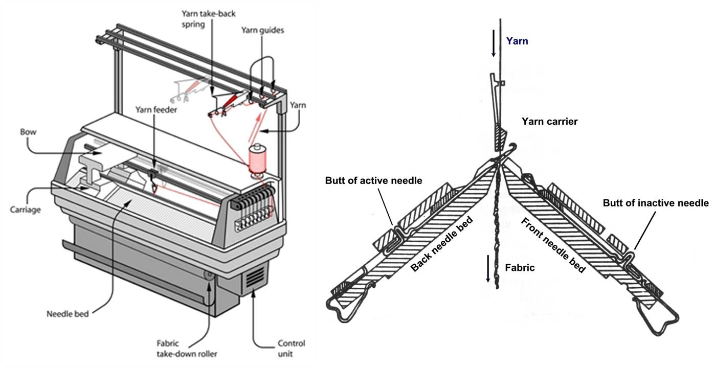

**Figure 12.10 V-bed knitting machine. Source Wood, 2010**

Two opposing needle beds, from 1.0 m to 2.2 m long, are positioned to form an inverted V. Needles slide down the beds in slots known as ‘tricks’. The carriage of the cam box traverses back and forth across the needle beds, selecting needles for knitting. The carriage raises and lowers the needles on both beds simultaneously as it passes over them, depending on the pattern required.

It is possible to produce either shaped panels (ie, fully fashioned) or body length of knitted fabrics, which are then cut to the desired shape. The panels are then linked together to form the garment.

**Patterning**

Stitches can be passed from one bed to the other, and the machines have huge patterning capabilities. The beds can be moved parallel to each other, a facility which allows panels to be shaped and also provides patterning capabilities using stitch transfer. Computer-controlled servo motors are mostly used to drive the yarn carriers, thereby enhancing the versatility of the machine to knit integral parts of garments. Garment parts such as pockets, collars, button holes and V-necks can be knitted as integral parts of the panel. The use of a computer workstation to programme and set up the machine for such detailed tasks saves time at the making-up stage.

**Complete garment machines**

From the 1970s machines have been available that produce a complete three-dimensional garment in one process without the need for sewing pieces of knitted fabric together. The machine’s computerised instructions direct the movements of hundreds of needles to construct and connect several tubular, knitted forms to create a complete garment in a single production step. Garments can be knitted quickly and without the waste of fabric and the formation of seams, both of which are issues with cut and sew techniques (Figure 12.11).

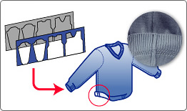 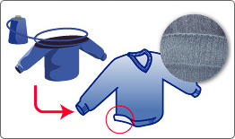

**Figure 12.11 Comparison between the cut and sew and complete garment methods (showing minimal waste and no seams in latter) Source: Wood, 2010.**

A Computer Aided Design System (CAD) is used to create the garment pattern, and this information is transferred to the knitting machine. To knit a sweater, three shaped tubes are knitted simultaneously. A front and a back needle bed are used to knit the tubes. Loops are formed and transferred between the front and back beds to create the shape. Three yarn carriers are used—one to knit the right sleeve, the second to knit the body and the third to knit the left sleeve. Once knitting reaches the under arm area, the three tubes are combined and the two carriers knitting the sleeves are taken out of the knitting zone. The carrier knitting the body begins to knit one tube—combining the three tubes. There are no real seams holding the garment together. The “complete garment” is made by knitting the three fabric tubes which are made up of a continuous spiral of yarn that has been formed into stitches. Each tube is knitted at the same time with a separate cone of yarn.

Complete garments can be knitted on special V-bed machines without the need for any making-up step. The two techniques are:

1. using an adapted V-bed machine, or
2. using four needle beds.

The two-bed machine is similar to a conventional V-bed machine, but uses coarser needles with larger hooks for the gauge (eg, 5gg needles in a 10gg machine) so that heavier yarns can be knitted. The yarn is knit on every second needle, leaving a needle available for transfer. Each stitch has an empty needle in the opposite bed to enable stitches to be transferred back and forth as required. The result is a 5 gauge fabric from a 10 gauge knitting machine.

Two-bed complete garment machines are wider than single panel width to allow for the body and two sleeves to be knitted side by side as tubes, which are shaped and linked as required. Four-bed machine use two beds for stitch transfer and knitting of ribs. The gauges are the same as for conventional V-bed machines, hence finer garments are possible than for two-bed machines.

Today’s complete garment machines, made by Shima Seiki (Japan) and Stoll (Germany), are capable of knitting a wide variety of constructions. Everything from a sheer to bulky knit fabric can be produced. Needles can be taken out of action to knit fabrics of different weights. Machines come in different gauges, allowing for a wide variety of yarns to be used.

The tubular panels are shaped just like any other piece of fully fashioned knitwear. Eventually all three panels become “one” to create the finished product. All cuffs, collars and waist bands are knitted at the same time and hence the garment comes off the knitting machine ready to wear. Virtually all the work is done by the knitting machine, so there are large labour and time savings. By eliminating seam allowances there is a further reduction in materials beyond fully fashioned production.

Complete garment knitwear is claimed to provide greater comfort than cut and sew clothes. Because of the absence of seams the fabric can fit close to the body and stretch more easily. Complete garment machines are also capable of producing complex designs; two-dimensional fabric is replaced by three-dimensional knitwear, shaped and pleated as required. Examples of knitted structures that are most often made using the complete garment technique are clothing (from sportswear to sweaters), gloves and technical textiles such as car seat covers.

**Circular knitting machines**

Circular knitting machines produce lengths of fabric in the form of a tube rather than panels or panels lengths. Garments must be made from the fabric via the cut and sew route, which creates waste. In addition, there are technical limitations in knitting, dyeing and finishing.

A circular machine greatly increases productivity because the relatively slow reciprocating motion of flat knit machines is replaced by a continuous and faster circular motion.

In addition, around a circular knitting machine there are multiple opportunities to introduce additional knitting stations. For example, modern machines may have 96 feed stations which means for each revolution of the machine the fabric grows by 96 courses.

Circular knitting machines mostly produce finer gauge products than the other machine. However, available gauges range from 5 to 32 gauge (needles per inch). Gauges suitable for wool jersey knitting are in the range 12 – 22 gauge.

Many types of circular knitting machines are used for specific applications, eg, interlock or terry loop. While there are models that allow knit, miss and tuck selections at each feeder, none match the versatility of flat knitting machines.

**Single jersey machines**

Single jersey machines are equipped with a single cylinder of needles for producing plain fabrics (single thickness) and derivatives of plain knits such as float jacquards and piques (Figure 12.12).

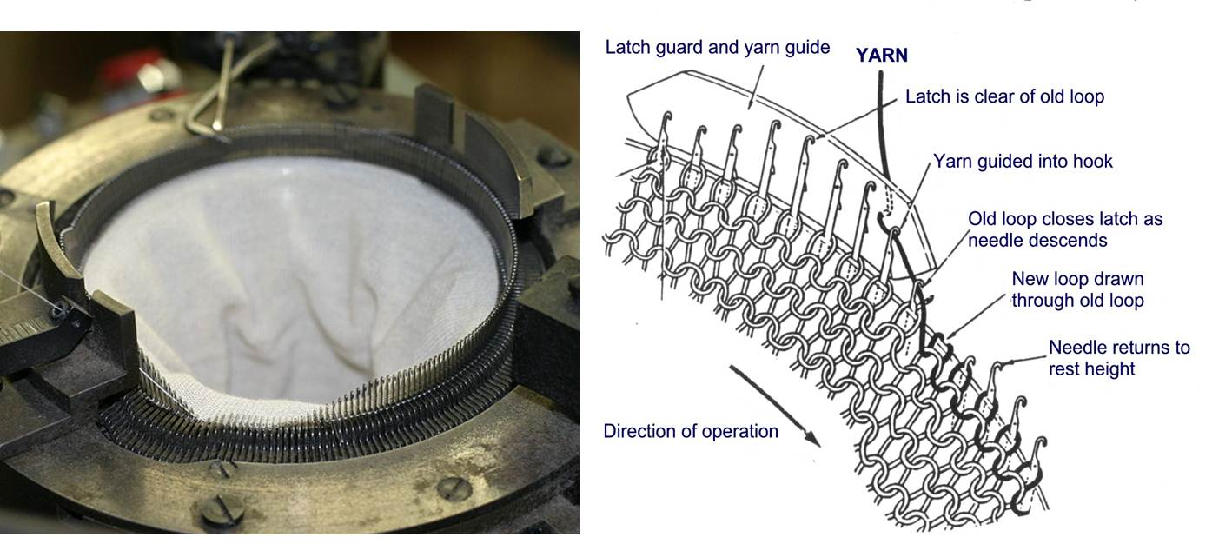

**Figure 12.12 Single jersey circular knitting. Source: Wood, 2010**

Wool fabric production on single jersey machines tends to be limited to 20 gauge or coarser, because these gauges can use two-fold yarns up to 48/2 Nm. Because of the balanced twist, the fabric deformation known as spirality is absent. On the other hand, finer gauges require singles yarn which produces spirality. Although singles yarn can be partially set during finishing, the knitted garment may subsequently twist during laundering. Fabrics are used in cut-and-sew garment manufacture and an inherent feature of wool single jersey fabrics is that the fabric edges tend to curl inwards after cutting.

**Double jersey machines**

Double jersey machines are single jersey machines with a ‘dial’. This houses an extra set of needles positioned horizontally, adjacent to the vertical cylinder needles (Figure 12.13). The extra set of needles allows the production of fabrics that are twice as thick as single jersey fabrics. The design possibilities are greatly enhanced, compared with single jersey machines. In general the dial knits the inner face of the fabric and the cylinder knits the outer face.

Wool double jersey fabric is more widely produced than single jersey. Typical examples are interlock structures for soft wool underwear and base layer garments, and 1x1 rib fabrics for leggings and outerwear products. Double jersey fabrics tend to be heavy so fine yarn counts are required. A typical yarn which is a compromise between knitting efficiency and cost is 48/1 Nm from merino wool of 21 micron or finer. Much finer yarns can be used because singles yarns do not give spirality problems in double jersey fabrics. This is because the double layer construction balances the yarn torque between the face and reverse sides.

High rates of production (eg, 25-50mm of fabric per revolution) are available from machines having 72, 96 or 108 yarn feeders. However, such machines are less suitable for knitting delicate wool yarns.

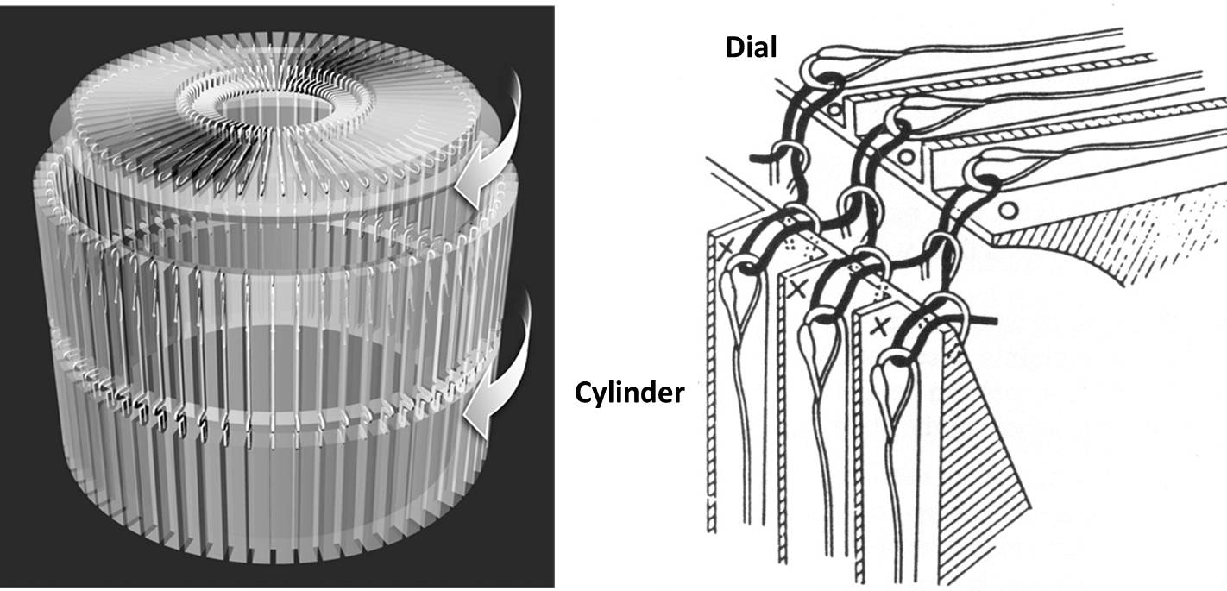

**Figure 12.13 Double jersey circular knitting. Source: Wood, 2010**

**Cut and sew**

The cut and sew technique is by far the simplest method of knitted garment construction. Individual panels shapes are cut to size from panels produced by V bed machines, or from the long length of fabric produced by circular knitting machines.

The benefits of the cut and sew route include:

* ease and speed of knitting fabric;
* consistency of cut panel sizes;
* relative ease of garment assembly.

The downside is that the seams must be overlocked prior to sewing or linking to prevent the exposed stitches from laddering. This produces a seam that is relatively large, bulky and unsightly.

The cut and sew route is not widely used for wool knitwear production because of the amount of potentially valuable material wasted (up to 25%) and the perceived “lower quality” image that such knitwear tends to have.

**Comparison of flat knitting and circular knitting**

Table 12.1 summarises the machines and products from the three weft knitting methods.

**Table 12.1 Summary of weft knitting**

|  |  |  |  |
| --- | --- | --- | --- |
|  | **V-bed machines** | **Circular machines** | **Fully fashioned** |
| Gauge | 3-18 needles per inch | 5-40 needles per inch | Normally 9-33 needles per 1.5 inches |
| Width | 78.7 inches (200 cm) | Usually ~30 inches diameter (76cm); up to 60 inches (152cm) available | From 2-16 section machines, each section up to 36 inches (91cm) wide; up to 40 section machines available |
| Needle type | Mostly latch (some compound) | Latch, some bearded and compound needle machines | Bearded or bearded and latch |
| Needle bed type | Mainly rib type | Single, rib, interlock, double cylinder | Single and rib |
| Products | Jumpers, pullovers, cardigans, dresses, suits, trimmings, hats, scarves, accessories, three-dimensional products for technical applications | Hosiery, dye bags, knit-de-knit yarns, industrial fabrics, underwear, T-shirts, jumpers, pullovers, cardigans, dresses, suits, vests, thermal wear, furnishing, upholstery, automotive, household and technical fabrics, | Jumpers, pullovers, cardigans, dresses, suits, fully fashioned hosiery, shorts shirts, underwear, thermal wear |

The following are generalized comments on flat knitting (ie, fully fashioned and V-bed) versus circular knitting:

**Versatility**:

Flat knitting is versatile in that it is possible to take one cone of yarn, commence knitting and produce one garment.

A circular knitting machine may require threading up with 96 cones of yarn, but this is the only viable option if a large quantity of fabric is to be produced.

**Patterning:**

It is possible to vary a pattern over the whole panel of a garment either by manual or jacquard control of a V-bed flat machine.

Circular machines to have patterning potential but such patterns are generally small motifs and evenly repeated through many metres of fabric.

**Width control**:

A flat machine can knit fabric of any width within the extremities of its needle bed width.

A circular knitting machine has a fixed circumference and knits on all needles, consequently the fabric produced has a width which is dictated by the machine diameter.

**Tubular fabric versus flat:**

The fabric produced on a V-bed machine is usually a flat piece of garment body, eg, front back or sleeve. It is however possible to print on the front and back needles and produce a tube of jersey fabric.

A circular knitting machine always produces a tube of fabric and subsequent processing dictates whether it remains a tube or is cut (split) and opened out into a flat fabric.

Tubular fabric is used for socks, seamless underwear and T-shirts. Each garment size requires a knitting machine of the appropriate diameter.

The flat knitting market generally uses large diameter knitting machines and the flat, open width fabric is cut and sewn in the normal way.

**Waste:**

Flat machines are often engineered to knit garment shapes so that the amount of waste is greatly reduced or completely eliminated. This is important when using expensive yarns such as those composed of superfine wool and/or specialty animal fibres.

Cut and sew garments using split jersey fabric always produce some waste fabric. However, the value of this waste is less significant when using cheaper yarns produced under high production knitting conditions.

**Finishing:**

V-bed flat knitting usually produces pieces (panels) which are sewn or linked together into garments for pressing and quick turnaround selling.

Circular knitted garment pieces usually require cutting and sewing.

Circular knitted fabrics require specialized finishing using expensive machinery, and considerable quality assurance measures to ensure consistency of fabric weight, length and width relaxation shrinkage.

**12.5 Fabric finishing**

Fabric leaving the knitting machine (in the greige state) require some finishing treatments to

1. remove any stresses within the fabric,
2. remove any processing contaminants from the fabric,
3. provide opportunities for creative processing if required to modify the appearance and handle of the knitted structure, for example, milling and surface raising.

The aim at all times is to ensure that the finished product is dimensionally stable. The tolerance limit acceptable to most users of knitwear is that it should lose no more than 5% in length and width, when subject to relaxation shrinkage. The second aim is to ensure that the fabric weight (in grams/metre2) remains within the tolerance limits.

Worsted-spun knitted garments require a smooth clear finish, with the stitches well defined. Steaming is used to release tensions in the yarns, and reduces the potential for relaxation shrinkage.

Woollen-spun knitwear may contain high levels of carding lubricant and scouring may be required to remove it. Milling (a gentle felting treatment) involves agitating a garment in a detergent solution to consolidate the structure, increase the fabric weight (per square metre), improve the handle and obscure the stitch structure by creating a hairy surface. To achieve such a finish, rotary drums, with programmable control of the various treatment cycles (washing, rinsing, milling), are often used.

**12.6 Knitted structures**

Four primary structures are the base structures from which all weft knitted fabrics are derived. They are:

* Jersey (or plain)
* Rib
* Purl, and
* Interlock.

Each is composed of a different combination of face and reverse-meshed stitches, which are knitted using a particular combination of needles.

**Jersey stitch**

The jersey stitch (or plain stitch) is the starting point for all knitted structures (Figure 12.14). The loops intermesh in one direction with the result that fabric has one appearance on the face side and a different appearance on the reverse side.

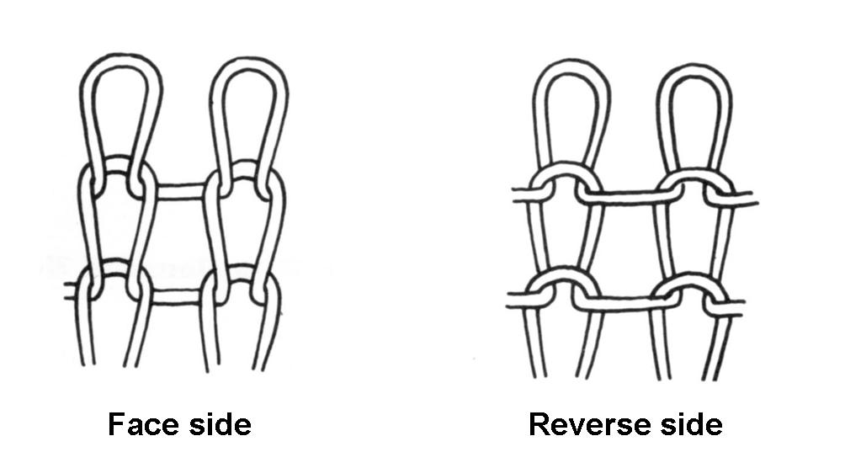

**Figure 12.14 Jersey stitch. Source: Wood, 2006.**

The jersey stitch is widely used in the knitting of sweaters, dresses, sport shirts and other items of sports wear. The characteristic of a single jersey fabric are:

* single sided
* thin/light weight
* fast and efficient production
* edges curl, making it difficult to handle
* partially unstable, susceptible to stitch distortion

These fabrics tend to roll at their edges due to the tendency of the yarn distorted into loops to try to straighten from this configuration.

The jersey stitch structure is extensible in both the lateral and longitudinal directions; however the lateral extension is twice the longitudinal extension. This because the yarn loop pulled in the longitudinal direction can extend by only half its length while when pulled in the longitudinal direction can extend by its entire length.

**Rib stitch**

The rib stitch has the same appearance on both sides, resulting from the fact that the stitches intermesh alternately on the face and reverse sides of the fabric (Figure 12.15). Thus the rib stitch is actually a blend of the two sides of the jersey stitch. Fabrics using the rib stitch are also known as double jersey or double face fabrics.

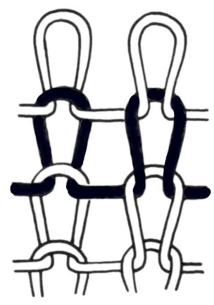

**Figure 12.15 1x1 rib stitch. Source: Wood, 2006.**

The term “rib” covers a broad range of knitted structures from: 1x1, 2x1, 2x2,. The simplest rib fabric is a 1x1 (as shown in Figure 12.15) and this is formed using 2 individual beds of needles whereby yarn passes from one bed to the other alternatively.

The rib stitch has excellent widthwise elasticity, especially fabric knitted in a 2 x 2 rib structure. Because of this inherent elasticity, yarn having a relatively low elasticity can be used. Consequently, the rib stitch is widely used in sleeve trims, sweater waistbands and collars. With rib structures, extensions of up to 140% can be achieved. However, as the number of wales in each rib increases the elasticity decreases, as the number of changeovers from reverse to front reduces.

An advantage of the rib stitch fabrics is that they do not curl at the edge and thus create no difficulty in cutting. The reason for the lack of curling is that the wales tend to counterbalance each other’s effect.

In summary, the characteristics of a 1x1rib fabric are:

* doubled sided
* thick/medium weight
* excellent width stretch/recovery
* balanced structure/fairly stable

**Interlock stitch**

The interlock stitch (Figure 12.16) is not actually a basic stitch but a variation of the rib stitch.

In construction it resembles two separate 1 x 1 rib fabrics that are interknitted, ie, it is knitted alternately on opposite needle beds, but on alternate needles. It requires two opposing knitted courses or traverses to complete one row. Thus the interlock stitch is thicker and heavier than rib stitch fabric of the same gauge. It has the same appearance on both sides, has good width stretch/recovery and is a stable, balanced structure.

The interlock stitch produces a fabric with an extremely soft handle, a high degree of fabric firmness and good moisture absorption. It is easy to handle in cutting and like all rib structures does not curl at the edges.

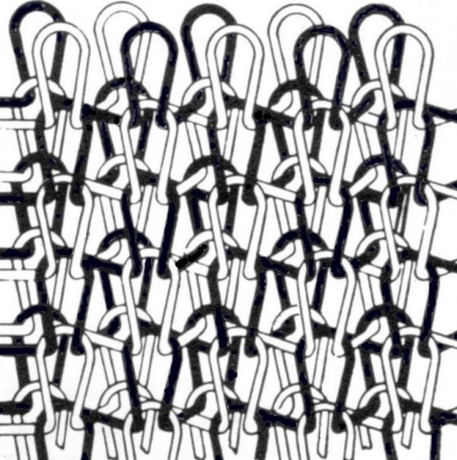

**Figure 12.16 Interlock stitch. Source: Wood, 2006.**

**Purl stitch**

The purl stitch is a combination of the reverse and face of the jersey stitch, but in a different way from the basic rib structure. Unlike the rib stitch, which has alternate wales of the face and reverse of jersey, the purl stitch produces alternate courses of the reverse and face of jersey (Figure 12.17).

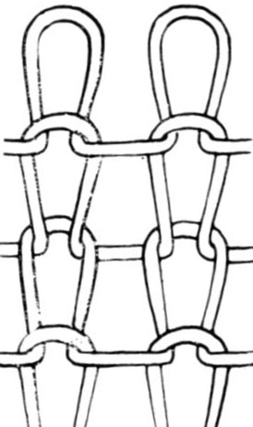

**Figure 12.17 Purl stitch. Source: Wood, 2006.**

The purl stitch is widely used in the manufacture of sweaters. From a design point of view it is probably the most versatile. Almost any design or stitch structure produced by hand knitting can be duplicated. Because the fabric has the same appearance on both sides, no problem of a face side occurs. A purl stitch fabric has excellent lengthwise elasticity, which is the reason for its extensive use in children’s wear.

**Variations in stitch structure**

Design can be introduced into knit fabrics using these basic stitches in various ways. The simplest method is to knit different coloured yarns at pre-determined intervals to produce stripe effects or to utilise fancy yarns such as a boucle or slub yarn. No change in the basic stitch structure occurs when these are introduced; the design is achieved solely by the constituent yarns.

Several methods are available to introduce design into knitting, such as

* Causing needles to produce a welt stitch (miss) or a tuck stitch;
* Varying or combining the three primary stitches.

The ***welt*** stitch is not actually a stitch. It is produced when a needle fails to capture the yarn as it is fed and the new yarn passes behind a previously held loop. The missed yarn thus floats on the reverse side of the fabric in unlooped form, as shown in Figure 12.18.

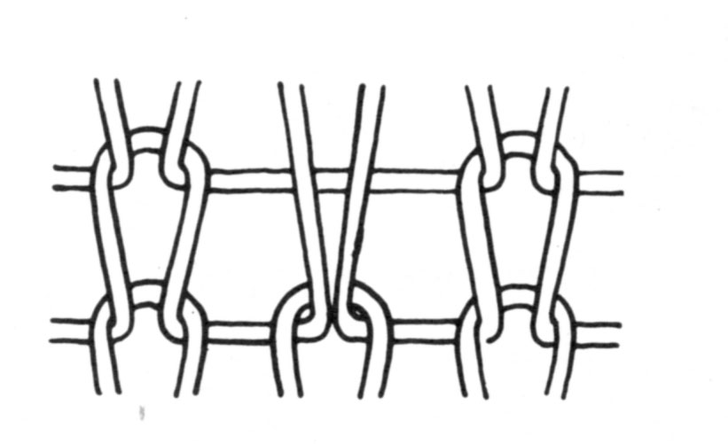

**Figure 12.18 Welt stitch. Source: Wood, 2006.**

The ***tuck*** stitch also produces a float but does not involve mis-knitting as in the case of the welt stitch. It is produced by accumulating two or more loops on a needle during the knitting cycle. A tuck loop occurs when the needle casts off the accumulated loops as one stitch. Next to the welt stitch it is the simplest and perhaps most widely used variation of the basic stitch formation. The result is a loop distortion as shown in Figure 12.19.

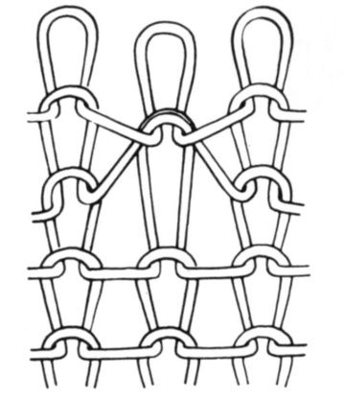

**Figure 12.19 Tuck stitch. Source: Wood, 2006.**

The distorted loop structure is different from that produced by the welt stitch because of the pile-up of loops. The tuck stitch is used in the knitting of jersey, purl and rib fabrics.

**Jacquard fabrics**

The origin of the term “jacquard” is in weaving rather than knitting. It came into use in 1804 to describe a technique developed by Joseph -Marie Jacquard of controlling the feeding of warp yarns in weaving using perforated cards. The term was not applied until much later when a similar perforated card system was devised as an attachment to V-bed flat knitting machines.

A knitted Jacquard fabric is one produced on a rib or purl machine in which the coloured pattern has been produced by knitting and welting (miss-knitting) selected needles. While perforated cards and pattern wheels are other mechanical devices have been used to control needle actions, modern machines are invariably computer controlled.

**12.7 The advantages and disadvantages of knitted fabrics**

The major benefits of knitted garments to the wearer are their comfort and retention of appearance. The loop structure provides the fabric with outstanding elasticity (ie, stretch and recovery), quite distinct from the elastic properties of the constituent fibres and yarns. Warmth and coolness are also important factors relating to comfort.

Because there is no single straight line of yarn anywhere in the pattern, a knitted fabric will be stretchy in all directions (with some more than others, depending on the yarn fiber and the specific pattern used). This stretchiness, not present with woven fabrics, is what originally made knitting so suitable for stockings. Many modern stretchy garments, even as they rely on elastic synthetic materials (eg, elastane fibres such as Lycra) for some stretch, also achieve at least some of their stretch through the knit structure.

Appearance retention means lack of wrinkling during wear, garment care, packaging or storage. Good recovery from crushing relies on the loop structure, but is also influenced by the fibre content and the type of yarn. Knitted products generally require no ironing.

The thickness of a knitted structure is three yarn diameters, compared with two yarn diameters for woven. This creates many dead air spaces and results in knitted garments with excellent insulating qualities in still air. However, in moving air (wind), the insulating effects are nullified because of the openness of the loop structure.

A unique advantage of the knitting industry is that it can produce a completed (ie, fully fashioned) garment on a knitting machine. In comparison with woven fabrics, less extensive fabric finishing treatments are required. Another advantage of knitting over weaving is the rate of production, but this is more than offset by the increased cost of yarn. There are two reasons for the higher cost:

1. Because the looped shape of the yarn imparts bulk, more yarn is required to produce a knit cloth of the same weight than a comparable woven cloth. As the yarn becomes finer the cost increases.
2. The looped structure is more porous and hence provides less cover than a woven fabric, so to achieve an equal amount of cover smaller stitches and finer yarns must be used.
3. Knitting yarns are expensive to make because they must be very uniform to prevent the formation of thick and thin places in the fabric.

Both knitted and woven fabrics can be produced in a multitude of designs. Multicoloured effects, textured designs, stripes and Jacquards are common to both types of structures. One area in which warp knits excel is the production of net fabrics. These are produced very economically and the structure is firmly locked in place.

Table 12.2 summarises the major differences between the processes of knitting and weaving, and the characteristics of the fabrics made by these processes.

**Table 12.2 A comparison of knitting and weaving. Source: Wood, 2006.**

|  |  |  |
| --- | --- | --- |
|  | **Knitting** | **Weaving** |
| Comfort and appearance retention | Mobile elastic fabric, adapts easily to body movement, good recovery from wrinkling | Rigid to stress (unless made with stretch yarns), varies with the weave |
| Handle | Soft bulky handle | Firm, smooth handle |
| Cover | Porous, more open spaces between yarns permits wind to penetrate | Provides maximum cover per weight of yarn, obstructing the passage of wind |
| Versatility | Design patterns can be changed quickly to meet fashion needs | Machinery less adaptable to rapid changes in fashion |
| Economics | Process is less expensive but is offset by more expensive raw material costs. Faster, regardless of fabric width | Most economical method of producing a unit of cover. Wider looms weave more slowly than narrow looms |
| Main product areas | Sportswear, underwear, hosiery | Suits, shirts, furnishings |

**Performance issues**

While knitted fabrics are inherent stretchy, and can therefore have dimensional stability problems, shrinkage control treatments, resin applications or heat setting (for synthetics) can provide good dimensional stability to garments. Knitted garments are regarded as ‘easy-care’ fabrics and in many cases machine washing and tumbling drying are approved treatments. However the dimensions will be retained best by dry cleaning, or by drying a washed garment lying flat.

The loop structure of knitted fabrics makes them especially susceptible to snagging. If a loop catches on a sharp object it may be pulled from the fabric surface and a long snap or pull of yarn formed. If the yarn is not broken, it can be drawn back into the fabric. If the yarn breaks, a hole may be formed and hand-stitching will be required to secure the yarns.

Synthetic double knits or knits made from loosely twisted yarns may be subject to pilling. As the fabric is subjected to abrasion during wear, the short fibre ends that work their way to the fabric surface are rubbed into a small ball that becomes attached to the surface. When these fibres are weak, as in cotton, wool, rayon, etc. the pills generally break free of the fabric. Stronger fibres cling to the fabric, making an unsightly appearance. Increasing the amount of twist in a wool yarn decreases the likelihood of pilling.

**Applications**

Knitted fabrics have a wide range of applications because of their mechanical properties and the characteristics acquired from the constituent yarns, or in finishing. The popular perception is that knitted fabrics are only appropriate to those end-uses where the properties of stretch, elastic recovery and air permeability are of primary importance. These end-uses include clothing worn next to the skin such as hosiery and underwear.

Knitted fabric need not be confined to these traditional applications. Its versatility enables it to be used across almost the entire field of textiles, from sheer hosiery, fines laces and hair nettings to heavy blanket, carpet and fur-like fabrics, and medical implants. (Kovar, 2002, pp 58-59) has a comprehensive list of knitted technical textiles.

|  |
| --- |
| **Readings**  The following readings are available on the web learning management system   1. Australian Wool Innovation Ltd, 2005. Fabric Appearance, from On The Wool Web - Technical Support for Wool Processors. Australian Wool Innovation, Sydney, Australia. 2. [Knitting Together](http://www.knittingtogether.org.uk/flatsite/cat.asp?cat=668). History and evolution of knitting machinery. The Heritage of the East Midlands knitting industry, since the 1500s. Retrieved 19th April, 2006 from website http://www.knittingtogether.org.uk. |

**Summary**

In machine knitting a series of needles is used to bend a yarn into loops and to interconnect these loops in a huge variety of ways to form a knitted fabric. Wool yarns with sufficient strength and evenness are required for this process.

A wide range of machines is available today for the industrial production of knitwear and hosiery, some with the advantage of high production speed while others offer complicated patterning and shaping capabilities. The complete garment machines are the most sophisticated knitting machines; these are able to produce an entire garment without seams or waste in a continuous process.

Some finishing of a knitted fabric or garment is generally required to make it acceptable in appearance, performance and handle for the consumer.

Advances in knitting technologies and fibres have led to a diverse range of products on the market, from high quality apparel to industrial textiles.

**References**

Australian Wool Innovation Ltd, 2010. [www.wool.com/knitting.htm](http://www.wool.com/knitting.htm)

Gohl, E P G and Vilensky, L D, 1983, Textiles for Modern Living, Longman Cheshire, ISBN 0 582 68831 0.

Kovar, R., 2002. Flat knitting technology. Knitting Technology, March 2, 2002, pp58-59.

Spencer, D J, 1986, Knitting Technology, Pergamon Press, ISBN 0-08-024763-6.

**Glossary of terms**

|  |  |
| --- | --- |
| Balanced yarn | A yarn that has no tendency to untwist or snarl when unconstrained |
| Barré | A fault in a weft-knitted fabric appearing as light or dark stripes in the course direction |
| Bulk | The space-filling ability of a yarn or fabric; inversely related to density |
| Cam | A device that moves the needles in a knitting machine up and down to produce the desired knitted pattern |
| Circular knit | Fabric or garment knitted in tubular form in a continuous operation so they are seamless |
| Course | A row of loops across the width of a knitted fabric |
| Cover factor | A number which indicates the extent to which the area of a knitted fabric is covered by the yarn. |
| Cylinder | Slotted section in circular knitting machine for holding needles |
| Dial | Circular steel plate with slots arranged radially. In rib knit production the needles operate in these slots in conjunction with the cylinder needles |
| Double knit | This describes any of the numerous fine rib knits that appear to have been knitted twice. The effect is produced by a two-needle construction which, in effect, is two single fabrics interlocked into one. These fabrics have the same appearance on each side. |
| Flat knitting machine | A weft-knitting machine having straight needle beds carrying independently operated latch needles. Also called ‘flat bed’. |
| Fully fashioned | Describes a knitted fabric or garment made on a flat knitting machine, with a shaped form achieved by adding or reducing the number of stitches at pre-determined points. |
| Gauge | Indicates fineness of knit texture as produced by a particular spacing of the needles in a machine. (The definition varies, depending on the type of machine; see (The Textile Institute, 1995). |
| Guide | A device that guides the yarn on to the needles in tricot and raschel warp knitting machines |
| Intarsia | A decorative, coloured motif knitted into a solid colour fabric A flat, single bed latch needle machine is used to produce this inlaid effect. |
| Interlock | A knit construction on a machine with alternate units of long and short needles. An interlock fabric is a double 1x1 rib fabric characterised by good lengthwise elasticity and firm texture |
| Jacquard | In a knitting machine, a mechanism for selecting individual knitting elements |
| Jersey | The most common type of knitted fabric, made by a single set of needles. It may be plain or ribbed and made on circular or flatbed machines |
| Knit | To form a fabric by the intermeshing of loops of yarn |
| Knitted loop | The basic unit of weft-knitted fabrics, consisting of a loop of yarn meshed at its base with a previously formed loop |
| Knitwear | A term usually applied to all knitted outwear garments excluding hosiery |
| Latch needle | A latch needle has a hook that open and closes by means of a swinging latch. |
| Needle bed | The flat slotted housing in a knitting machine in which the needles move. The number slots in the needle bed represents the gauge. |
| Needle trick | A slot in the needle bed in which a needle moves back and forth |
| Pique | This type of knit is characterised by a distinctive waffle-like or honeycomb surface appearance. |
| Plain knit | The simplest of all knit structures, as in jersey and hosiery cloth. It consists of vertical rows (wales) on the fabric face, and crosswise lines (courses) on the back. |
| Purl machine | A weft knitting machine of the flat bed type having two needle beds horizontally opposed in the same plane. |
| Raschel | A warp knitting machine which uses latch needles set in one or two needle bars and employing multi-guide bars. Many types of lace and net-like effects can be produced, as well as surface patterns. |
| Rib knit | A knit fabric with lengthwise ribs formed by the wales alternating on the face and back sides If every other wale alternates it is called 1x1 rib, if two wales alternate it is called 2x2 rib etc. |
| Rib knitting machine | A weft knitting machine of flat-bed type having two needle beds which are opposed to each other in inverted V formation (also called V-bed) |
| Sinker | A divider blade which moves or pushes the yarn alternately between the needles. It holds down the fabric, permitting the needle to function, and acts as a loop-forming device in conjunction with the needle. |
| Spirality | The deformation by skewing of a knitted structure due to the yarn twisting within the structure. The vertical lines of stitches (wales) are no longer at right angles to the horizontal lines of stitches (wales). |
| Stitch density | Number of stitches per unit area of knitted fabric. |
| Tricot | A warp-knitted fabric knitted with two sets of warp threads, widely used for swimwear, active garments and foundation wear. |
| Rib fabric | A weft-knitted fabric in which both back and face loops occur along the course, but in which all the loops in a single wale are of the same type (back or face) |
| Wale | The series of loops, formed by one needle, that run lengthwise in a knit fabric. |
| Warp knitting | A knitting method where the loops made from each warp thread are formed across the width of the fabric. Each weft thread is fed more or less at right angles to the direction in which the fabric is produced. The fastest method of converting yarn into fabric. |
| Weft knitting | A knitting method where the loops made from each warp thread are formed along the length of the fabric. Each warp thread is fed more or less in line with the direction in which the fabric is produced. |
| Welt stitch | An effect produced when the needle mis-knits or fails to receive the fed yarn for the space of a loop. The missed yarn thus remains on the back of the fabric in unlooped form. |